Computer and Communication

Networks

EE-357

BEE-9

Submitted by:

Sardar Hassan (223488)

Abdul Rehman (237532)

Table of contents:

| Page Number | Contents |
| --- | --- |
| 3 | Overview & Implementation |
| 4 | Implementation |
| 5 | Diagram of working principle |
| 6 | Receiver side functions & Sender  side functions |
| 7-13 | Receiver side code |
| 14-16 | Sender side code |

Overview:

The purpose of this project is to make UDP more reliable. This is done by introducing Acknowledgement (ACK) and Negative Acknowledgement (NACK) messages to make certain that our packets are delivered. We also introduce packet number in order to reorder the packets once they arrive at the receiver. Furthermore, we have also restricted our packet payload size to 500 bytes and have introduced a window size, which is to be between 5 and 10.

Implementation:

1. Window size:
   * We defined a variable in the receiver side code which defines the desired window size as a string.
   * At the start of transferring the data file, the sender asks the user what the window size is.
   * The receiver then replies with the window size which is stored as a string on the sender side.
2. ACK and NACK messages:
   * We adjusted the payload by giving 495 bytes to the audio file data and the remaining 5 bytes of data to the packet number being sent.
   * At the receiver side, we started a master counter that would start from 0 and would increment after every packet arrived.
   * We then made our own buffer to hold the packet/sequence numbers and we defined a function that would run through the buffer and check if any packet number was missing by comparing them to the master counter.
3. Retransmission:
   * Retransmission, if required, is accomplished after the ACK and NACK messages check.
   * If there is a need for retransmission, the receiver sends the a NACK message, which is stored at both sides, along with the required packet number.
   * The sender then retransmits the required packet and waits for any other retransmission requests. If there aren’t any, the receiver transmits a ‘No More’ (NM) message (which is stored on both sides).
4. Reordering of packet:
   * The reordering of the received packets was done after the ACK and NACK message check and retransmission (if any).
   * We wrote a function that would do a bubble sort of the packet/sequence number buffer.
   * If there are any changes, the same changes were made in the data buffer.
   * We realize that bubble sort is not an elegant and efficient sorting algorithm, but it will do for the purpose of our project since the buffer size in small (the buffer size the same as the window size, between 5 and 10).
5. Restriction of packet payload to 500:
   * The packet payload is restricted by simply setting the buffer size to 500 while transmitting the packet.
6. Indicating no more data left to be transferred:
   * We have programmed the sender to send a ‘FIN’ message to the receiver when there is no more data to be sent.
   * The receiver, upon receiving the ‘FIN’ message, closes the file and ends the transmission.

**Note: Do not forget to add the audio files to path, and check that you have the correct file names.**

**Note: The sender side code contains a NACK message check case that intentionally misses out packet number 12 and packet number 100 when sending data to the receiver. This to confirm that the NACK message is sent, and the required packets are correctly received.**

Diagram of working principle: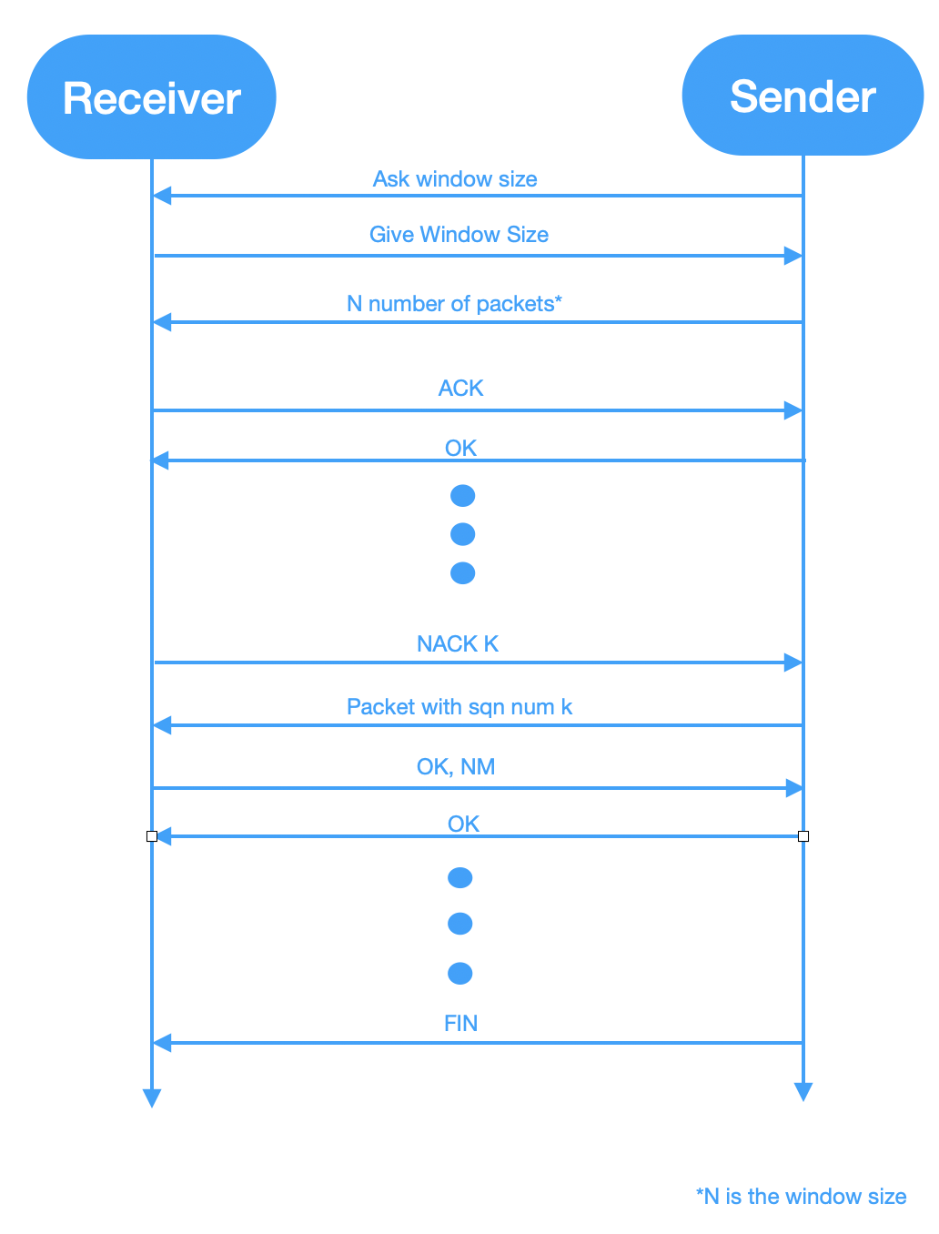

Receiver side functions:

| Function Name | Purpose |
| --- | --- |
| give_window_size | To see if the sender has asked for the window size, and if yes, send it to them. |
| bubble_sort | Sort the contents of the packet number buffer and make the same changes in the data buffer. |
| store_buffer | Store the contents of the incoming packet payload to the associated buffers and set the sequence number. |
| send_ack | Send the stored acknowledgement buffer to the sender. |
| empty_buffers | Empty the contents of the data and packet number buffers by using the pop function. |
| send_correct_message | Check if the sender requires the ACK, NACK, OK, NM message to be sent again. |
| check_missing | To check if there is a missing packet, by comparing the contents of the packet number buffer and the master counter. If yes, it calls store_buffer and bubble_sort. |

Sender side functions:

| Function Name | Purpose |
| --- | --- |
| ask_window_size | Get the window size from the receiver. |
| send_data | Sends the contents of the audio file along with the packet number to the receiver. |
| check_message | Check the incoming messages from the receiver. If it is a NACK message, send the required packet again. If it is an ACK message, continue on. This function responds to other messages accordingly. |
| empty_buffers | Empty the contents of the data and packet number buffers by using the pop function. |

Receiver side code:

#created by sardar hassan and abdul rehman qamar aftab

from socket import *

import select

import sys

import time

window_size="10" #set window size

ip_addr="127.0.0.1" #server ip address

port_num=55000 #server port number

client_port=50000

timeout=3 #no of seconds to wait till timeout

file_to_save=“from_sender.mp3" #<---------------------------file name where we save data

open_mode="ab" #<--------------------------------------------file open mode

buffer_size=500 #set buffer length to to 500 bytes of packet

remaining=5

master_counter=0

packet_lost=False

fin_recieved=False

ack_message="ACK"

nack_message="NACK"

send_again_message="Send again"

ack_message="ACK"

nack_message="NACK"

ok_message="OK"

nm_message="NM"

fin_message="FIN"

from_us=ack_message #default from us message

sqn_num_prefix= "0" #set prefix digits of syn number

ack_num="0" #set ack number to zero

sqn_num="0"

data_buffer=[""]

sqn_num_buffer=[""]

nack_buffer=[""]

fsqn_num_buffer=[""]

temp4=[""]

temp5=[""]

counter=0

#temp 2 for storing

#temp 3 is len of data buffer

#temp 4 is for sqn num buffer, not used

#temp 5 is for data buffer

#temp 6 for nack buffer

#bind socket

udp_sock=socket(AF_INET,SOCK_DGRAM)

udp_sock.bind((ip_addr,port_num))

#custom define bubble sort

def bubble_sort(sqn_arr,data_arr):

temp3=len(data_arr)

print "recieved sqn nums are:", sqn_num_buffer[1:temp3],

index = len(sqn_arr) - 1

while index >= 1:

for j in range(1,index):

if int(sqn_arr[j]) > int(sqn_arr[j+1]):

sqn_arr[j], sqn_arr[j+1] = sqn_arr[j+1], sqn_arr[j]

data_arr[j], data_arr[j+1] = data_arr[j+1], data_arr[j]

index -= 1

print "reordered sqn nums are:", sqn_num_buffer[1:temp3],

print ""

return sqn_arr,data_arr

#storring function

def store_buffer(sqn_num_buffer,data_buffer,message,fin_recieved,sqn_num,master_counter):

if message != fin_message: #if not FIN recieved

temp1=len(message) #length of message

temp2=buffer_size-len(message)

if temp2==4: #for single digit sqn num

sqn_num=message[temp1-1]

print "Sqn num is",sqn_num

sqn_num_buffer.append(sqn_num)

data_buffer.append(message[0:temp1-1])

elif temp2==3: #for double digit sqn num

sqn_num=message[temp1-2:temp1]

sqn_num_buffer.append(sqn_num)

print "Sqn num is",sqn_num

data_buffer.append(message[0:temp1-2])

elif temp2==2: #for three digit sqn number

sqn_num=message[temp1-3:temp1]

print "Sqn num is",sqn_num

sqn_num_buffer.append(sqn_num)

data_buffer.append(message[0:temp1-3])

elif temp2==1: #for four digit sqn number

sqn_num=message[temp1-4:temp1]

print "Sqn num is",sqn_num

sqn_num_buffer.append(sqn_num)

data_buffer.append(message[0:temp1-3])

elif master_counter>=10000: #for five digit sqn number

sqn_num=message[temp1-5:temp1]

print "Sqn num is",sqn_num

sqn_num_buffer.append(sqn_num)

data_buffer.append(message[0:temp1-3])

else: #for file data less than buffer_size - remaining

if master_counter<10: #for single digit sqn num

sqn_num=message[temp1-1]

print "Sqn num is",sqn_num

sqn_num_buffer.append(sqn_num)

data_buffer.append(message[0:temp1-1])

elif master_counter<100: #for double digit sqn num

sqn_num=message[temp1-2:temp1]

print "Sqn num is",sqn_num

sqn_num_buffer.append(sqn_num)

data_buffer.append(message[0:temp1-2])

elif master_counter<1000: #for triple digit sqn num

sqn_num=message[temp1-3:temp1]

print "Sqn num is",sqn_num

sqn_num_buffer.append(sqn_num)

data_buffer.append(message[0:temp1-3])

elif master_counter<10000: #for four digit sqn num

sqn_num=message[temp1-4:temp1]

print "Sqn num is",sqn_num

sqn_num_buffer.append(sqn_num)

data_buffer.append(message[0:temp1-4])

elif master_counter<100000: #for five digit sqn num

sqn_num=message[temp1-5:temp1]

print "Sqn num is",sqn_num

sqn_num_buffer.append(sqn_num)

data_buffer.append(message[0:temp1-5])

else:

fin_recieved=True

return sqn_num,sqn_num_buffer,data_buffer,fin_recieved

def send_ack(): #send ack

udp_sock.sendto(ack_message,(ip_addr,client_port)) #send ack

time.sleep(0.05)

print ack_message

def empty_buffers(data_buffer,sqn_num_buffer,nack_buffer): #empty buffers

temp3=len(data_buffer)

for k in range(temp3-1,0,-1):

data_buffer.pop(k)

sqn_num_buffer.pop(k)

#empty nack buffer

if len(nack_buffer)>1:

temp6=len(nack_buffer)

for k in range(temp6-1,0,-1):

nack_buffer.pop(k)

return data_buffer,sqn_num_buffer,nack_buffer

def send_correct_message(from_us):

while(1): #check for getting correct message

message, address = udp_sock.recvfrom(buffer_size) #get message

print message

if message==send_again_message: #if asked to send again

udp_sock.sendto(ack_message,(ip_addr,client_port)) #send message

time.sleep(0.05)

elif message==ok_message:

break

def give_window_size(message,counter,master_counter):

if message=="Window size?": #if window size asked

print "Sender:",address[0],", message:",message #print the in comming message

udp_sock.sendto(window_size,(ip_addr,client_port)) #send the window size

time.sleep(0.05)

counter=-1 #reinitialise counter

master_counter=-1

else:

for i in range(buffer_size-3):

f1.writelines(message[i]) #write incomming data

print "Data coming from ip address:",address[0]

sqn_num=message[buffer_size-3:len(message)]

print "sqn num is ", sqn_num #print single digit sqn number to shell

counter=counter+1

master_counter=master_counter+1

return master_counter,counter

def check_missing(master_counter,counter,sqn_num_buffer,data_buffer,packet_lost,from_us,fin_recieved):

temp3=len(data_buffer)

t=master_counter-counter

i=1

while i<temp3:

if sqn_num_buffer[i]!=str(t+i-1): #if sqn num missing

packet_lost=True

#ask for missing packet

while(1):

udp_sock.sendto(nack_message+str(t+i-1),(ip_addr,client_port)) #send nack

time.sleep(0.05)

message, address = udp_sock.recvfrom(buffer_size) #get packet

master_counter +=1 #increment master counter

counter += 1 #increment counter

sqn_num,sqn_num_buffer,data_buffer,fin_recieved= store_buffer(sqn_num_buffer,data_buffer,message,fin_recieved,sqn_num_buffer[i],master_counter)

sqn_num_buffer,data_buffer=bubble_sort(sqn_num_buffer,data_buffer)

if sqn_num_buffer[i]==str(t+i-1): #if correct recieved

#send ok

udp_sock.sendto(ok_message,(ip_addr,client_port))

print ok_message

if temp3 <= int(window_size)+1: #while temp3 is in range

temp3 +=1 #increment temp3

break

i+=1 #increment i

if len(data_buffer) != int(window_size)+1: #buffer not full

if fin_recieved==False:

while(len(data_buffer) != int(window_size)+1) and fin_recieved==False:

#send nack

udp_sock.sendto(nack_message+str(t+i-1),(ip_addr,client_port)) #send nack

print str(t+i-1)

time.sleep(0.05)

message, address = udp_sock.recvfrom(buffer_size) #get packet

packet_lost=True

master_counter +=1 #increment master counter

counter += 1 #increment counter

sqn_num,sqn_num_buffer,data_buffer,fin_recieved= store_buffer(sqn_num_buffer,data_buffer,message,fin_recieved,sqn_num_buffer[i-1],master_counter)

sqn_num_buffer,data_buffer=bubble_sort(sqn_num_buffer,data_buffer)

if sqn_num_buffer[i]==str(t+i-1): #if correct recieved

#send ok

udp_sock.sendto(ok_message,(ip_addr,client_port))

print ok_message

if temp3 <= int(window_size)+1: #while temp3 is in range

temp3 +=1 #increment temp3

i +=1

if packet_lost==False:

#print ack

send_ack()

from_us=ack_message

#send No more messgae

if packet_lost==True:

udp_sock.sendto(nm_message,(ip_addr,client_port))

print nm_message

return sqn_num_buffer,data_buffer,from_us,packet_lost,master_counter,counter,fin_recieved

print "ready to serve"

#main while loop

while True:

f1=open(file_to_save,open_mode) #open file for appending

message, address = udp_sock.recvfrom(buffer_size) #recieve message

if message: #if message recieved

master_counter,counter=give_window_size(message,counter,master_counter)

while True: #secondary loop

temp=select.select([udp_sock],[],[],timeout)

if temp[0]: #if messages still coming

packet_lost=False

master_counter += 1

counter += 1

message, address = udp_sock.recvfrom(buffer_size)

#storring function

sqn_num,sqn_num_buffer,data_buffer,fin_recieved=store_buffer(sqn_num_buffer,data_buffer,message,fin_recieved,sqn_num,master_counter)

#print "time difference=",time_difference

if (counter==int(window_size)-1 ): #if window size reached

temp3=len(data_buffer) #length of data buffer

#reordering of packets

sqn_num_buffer,data_buffer=bubble_sort(sqn_num_buffer,data_buffer)

#check for missed packets

sqn_num_buffer,data_buffer,from_us,packet_lost,master_counter,counter,fin_recieved= check_missing(master_counter,counter,sqn_num_buffer,data_buffer,packet_lost,from_us,fin_recieved)

send_correct_message(from_us)

packet_lost=False

f1.writelines(data_buffer[1:temp3])

#empty buffers

data_buffer,sqn_num_buffer,nack_buffer=empty_buffers(data_buffer,sqn_num_buffer,nack_buffer)

counter=-1 #reinitiase counter

elif not temp[0]: #no incoming data

#check for packet loss

sqn_num_buffer,data_buffer,from_us,packet_lost,master_counter,counter,fin_recieved= check_missing(master_counter,counter,sqn_num_buffer,data_buffer,packet_lost,from_us,fin_recieved)

#to see if correct message sent

if fin_recieved==False or (master_counter+1)%int(window_size)!=0: #if not end of transfer

send_correct_message(from_us)

if packet_lost==False:

#reordering of packets

sqn_num_buffer,data_buffer=bubble_sort(sqn_num_buffer,data_buffer)

temp3=len(data_buffer) #length of data buffer

print "remaining buffer size is",temp3

#write data in to file

if counter >=0:

f1.writelines(data_buffer[1:temp3])

#clean up buffers

data_buffer,sqn_num_buffer,nack_buffer=empty_buffers(data_buffer,sqn_num_buffer,nack_buffer)

counter=-1 #reinitialise counter

#close file

if packet_lost==False or fin_recieved==True:

f1.close()

print "file closed"

if fin_recieved==True:

print fin_message

fin_recieved==False #reset fin recieved

break #break secondary loop

udp_sock.close() #close socke

Sender side code:

#created by sardar hassan and abdul rehman qamar aftab

from socket import *

import time

import sys

#set server IP, port number

serverName="127.0.0.1"

serverPort=55000

my_port=50000

file_name="to_send.mp3" #🡨-----------------------------------------------file to transfer

open_mode="rb" #<----------------------------------------------------------file open mode

buffer_length=495 #set packet payload length to 495 bytes of packet

remaining=5

sqn_num="0"

counter=0

ack_message="ACK"

nack_message="NACK"

send_again_message="Send again"

ok_message="OK"

nm_message="NM"

fin_message="FIN"

temp=0

test=False

data_buffer=[""]

sqn_num_buffer=[""]

#temp for sqn num

#temp 3 for data buffer

#temp 4 for nack sqn

clientSocket = socket(AF_INET,SOCK_DGRAM)

clientSocket.bind((serverName,my_port))

def send_data(sqn_num_buffer,data_buffer): #to send data to reciever

temp3=len(data_buffer)

for k in range(1,temp3):

if sqn_num_buffer[k]!="12" and sqn_num_buffer[k]!="100":

clientSocket.sendto(data_buffer[k] + sqn_num_buffer[k],(serverName,serverPort)) #send data one by one

time.sleep(0.05) #wait

#clientSocket.sendto(data_buffer[k] + sqn_num_buffer[k],(serverName,serverPort)) #send data one by one

#time.sleep(0.05) #wait

print "sqn num is",sqn_num_buffer[k] #print syn number

def check_message(sqn_num_buffer,data_buffer): #if incomming message is correct

message,address=clientSocket.recvfrom(buffer_length)

print "entered check message"

while(1): #check for getting correct message

if message[0:len(nack_message)]==nack_message: #if nack recieved

temp3=len(data_buffer)

print message

while(1):

req_sqn=message[len(nack_message):len(message)]

for i in range(1,temp3):

if sqn_num_buffer[i]==req_sqn:

while(1):

clientSocket.sendto(data_buffer[i] + sqn_num_buffer[i],(serverName,serverPort))

time.sleep(0.05) #wait

message,address=clientSocket.recvfrom(buffer_length)

if message==ok_message:

break

message,address=clientSocket.recvfrom(buffer_length)

if message==nm_message: #if nm message recieved

clientSocket.sendto(ok_message,(serverName,serverPort))

time.sleep(0.05) #wait

break

break

elif message==ack_message: #if ack recieved

print message

clientSocket.sendto(ok_message,(serverName,serverPort))

time.sleep(0.05)

print ok_message

break

def empty_buffers(sqn_num_buffer,data_buffer):

temp3=len(data_buffer)

for j in range(temp3-1,0,-1):

data_buffer.pop(j)

sqn_num_buffer.pop(j)

print "remaining sqn num buffer:",sqn_num_buffer

def ask_window_size():

#ask for window size

print"Asking for window size..."

prompt="Window size?"

clientSocket.sendto(prompt,(serverName,serverPort))

time.sleep(0.05)

#get and store window size

message,address=clientSocket.recvfrom(buffer_length)

print "From reciever window size is",message

return message

window_size=ask_window_size()

f = open(file_name, open_mode) #open file for reading

data=f.read(buffer_length) #get data to send

while data: #while data remaining to send

#store data and sqn numbers in buffer

data_buffer.append(data)

sqn_num_buffer.append(sqn_num)

if counter==int(window_size)-1:

temp3=len(data_buffer)

send_data(sqn_num_buffer,data_buffer) #send data

check_message(sqn_num_buffer,data_buffer) #check for incominng message

#pop sent sqn number and data

empty_buffers(sqn_num_buffer,data_buffer) #empty the buffers

counter=-1 #reinitialise counter

temp=int(sqn_num)+1 #increment syn num

sqn_num=str(temp)

data=f.read(buffer_length) #get remaining data

counter += 1

#for last few packets

print "remaining counter is:", counter

if counter>0: #if any remaining packets

temp3=len(data_buffer) #data buffer length

#send data and sqn number one by one from buffer when window size reached

send_data(sqn_num_buffer,data_buffer)

#pop sent sqn number and data

empty_buffers(sqn_num_buffer,data_buffer)

#send fin

clientSocket.sendto(fin_message,(serverName,serverPort))

time.sleep(0.05)

#recieve messages

check_message(sqn_num_buffer,data_buffer) #check for incominng message

clientSocket.close() #close socket

print "File closed”